Profile Essay
Purpose statement: To describe what is love and persons of interest in my life
Audience: My tutor, Fellow students, colleagues.
Genre: Descriptive essay
Name:
Professor’s name:
Date:

Place portrait
Al Janadriyah festival started in 1985 and is sponsored by the Saudi National Guard. Al Janadriyah Festival takes place in Janadriyah village is situated in Janadriyah road. It is opposite the Salwa Garden, which is North of Riyadh. Straight from the city centre, it can take one only 40Km to get to Janadriyah. King Abdul Aziz Race track and the Thumamah National park neighbor Janadriyah village. Three roads head to Janadriyah and can only take users 30-40 minutes to arrive at Janadriyah. Unfortunately, there is no public transport offered to access Janadriyah. Al Janadriyah Festival is the best annual festival in Saudi Arabia. It is held during the winter in the month of February or March. The event has a variety of sports and activities such as dancing. Other items that can be found in the festival include; traditional arts, crafts, falconry as well as government institutions, parastatals all of which assemble there to showcase their products, services and many other relevant items. Visitors enjoy visiting the place and strolling past the pavilions while looking at the iconic artefacts and the rich history displayed. The festival has a variety of food in this place. The cuisines, Shawarma and other cultural foods are available in the event.
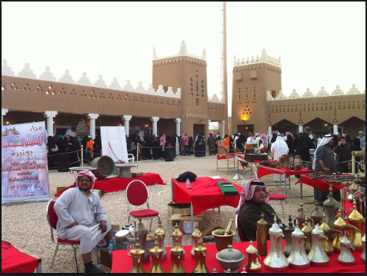
The toys in the fair are awesome. The festival is culminated by Saudi women wearing the cowboy hats and abayas, which is not common considering the religion standings. The transit of the festival in Riyadh and the moment's families share together is memorable for all those who attend the event. The place smells wonderful from the different colognes from both the local and the expatriate visitors. It is a place where people meet and enjoy. Activities such as camel riding, and other activities make the place and the event busy and visitors can have any fun they like/love. The music is soothing and cultural. Visitors are treated to ancient artefacts, sail making endeavours, and different foundations of Islam.
The festival starts with an opening ceremony master and then various events starts such as Carmel racing. The last time I attended the event is early this year in late winter/early spring outside the city of Riyadh. The event normally attracts people both local and international, it is also a chance for the people of Saudi to showcase their culture as well as let their hats down. The visitors walk through looking at the local arts and crafts and the people in charge ready to explain to them about their history. The food is readily available as one can eat her or his way across the stands. Across the stands there are displays that are hosted by the government especially the military however, each year there is a display that is hosted by international government as a way of improving their relationship with the international governments. Specialists in the anti-corruption programs, public relations and media as well as in the integrity protection are readily available to answer any question concerning the event as well as receive the feedbacks.
The festival contains the signboards about the programs of the day, events, workshops, programs as well as research implemented by Nazaha regarding fighting corruption as well as integrity protection. The festival also contains screens with the videos as well as workshops for the children. There is also a pavilion at the festival featuring the UAE cultural film that is used by people in charge to shed light on special elements such as traditional architecture. There is also three photographic exhibitions that portray the main and important historical events. The first one is about the traditionally strong Saudi-emirates relations. The second contains a collection of cultural photographs of the UAEs past regime. The third contains the tourist attraction sites as well as tourism as whole. The pavilion focuses mainly on the traditional heritage materials and traditional arts.
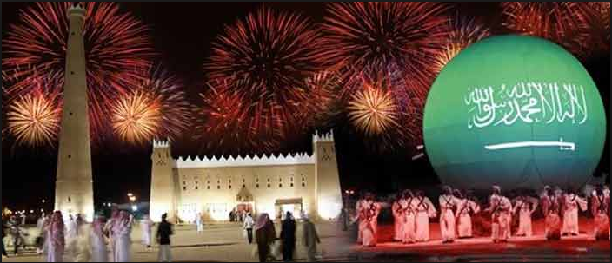
There was an Indian pavilion focusing mainly on the Indian culture as well as their heritage materials. Apart from an Indian pavilion there was a seminar at a hotel min Riyadh with different speakers speaking present realities and future prospects. They will also discuss about the economic cooperation and investment opportunities. The seminar is also expected to touch the main activities of Saudi as well as address their main problems. This is a main event to the people of Saudi as well the world at large to learn more about Saudi.

References
Abdelazim, T. S., & Alajloni, A. A. (2016). Towards developing a model to assess the experience of visitors of the Janadriyah festival, Saudi Arabia. International Journal of Tourism Cities, 2(1), 45-76.
Al-Saif, T. (2014). Political Islam in Saudi Arabia: recent trends and future prospects. Contemporary Arab Affairs, 7(3), 398-420.
Curtiss, R. H. (2015). Two Dedicated Saudi Volunteers: Preserving on Film the Natural and Cultural Heritage of Saudi Arabia. The Washington Report on Middle East Affairs, 14(3), 57.
Mohammad, B. A. A. (2014). Festival tourism in Saudi Arabia: a study of image and motivation of participating in Janadriyah festival. American Journal of Tourism Management, 3(2), 45-54.

